# <https://www.alibaba.com/product-detail/Under-Sink-6-Stage-75GPD-Reverse_1600559402848.html?spm=a2700.galleryofferlist.normal_offer.d_title.189b8461Bw1AEM>

# Under Sink 6 Stage 75GPD Reverse Osmosis System With Alkaline Mineral pH+ 100GPD ro system water filter

Minimum order quantity: 1 piece

**$49.89 - $75.60**

**Key attributes**

**Industry-specific attributes**

Warranty

3 years

Application

Commercial, Household

**Other attributes**

Place of Origin

Guangdong, China

After-sales Service Provided

Overseas Call Centers

Power Source

Electric, Manual

App-Controlled

NO

RO Filter Life

12 Months

Function

TDS Monitoring, self-cleaning, Filter Life Display, Smart Faucet

Filtration Stages

5

Brand Name

Royol or OEM

Model Number

RYRO1215

Power (W)

none

Voltage (V)

none

Type

Under-Sink

Private Mold

Yes

Product name

Water filter system/RO system

Size

10/20 inch

Fiter housing color

white clear blue green orange

Filter Cartridge

PP+CAG+CTO+RO/UF+T33

Filtration Life

1 month - 1 year

Function

Purifier water

Packing

Carton Box

Applicable water source

Well water, tap water

**Packaging and delivery**

Packaging Details

carton as picture

Port

shenzhen port

Selling Units:

Single item

Single package size:

61X31X47 cm

Single gross weight:

18.000 kg

**Supply Ability**

Supply Ability

100000 Piece/Pieces per Month

**Lead time**

|  |  |  |
| --- | --- | --- |
| Quantity (pieces) | 1 - 5000 | > 5000 |
| Lead time (days) | 15 | To be negotiated |

**Samples**

Maximum order quantity: 2 piece

Sample price:

**$70.00/piece**

Order sample

**Overview**

Products Description

|  |  |
| --- | --- |
| Product name | Water purifier filter/Reverse Osmosis System/Water dispenser |
| Custom label | Yes!   You can provide your label files to us or we can design your label according to your mind |
| Filter cartrige | PP+CAG+CTO+RO/UF+T33 |
| Spare parts | Yes!  we can provide all the spare parts service for you forever |
| Color (filter housing) | We have all kinds of color for the filter housing, Clear White Blue Orange Green |
| MOQ | 1 pcs |
| Packaging | Carton box.  and we have regular carton packaging |

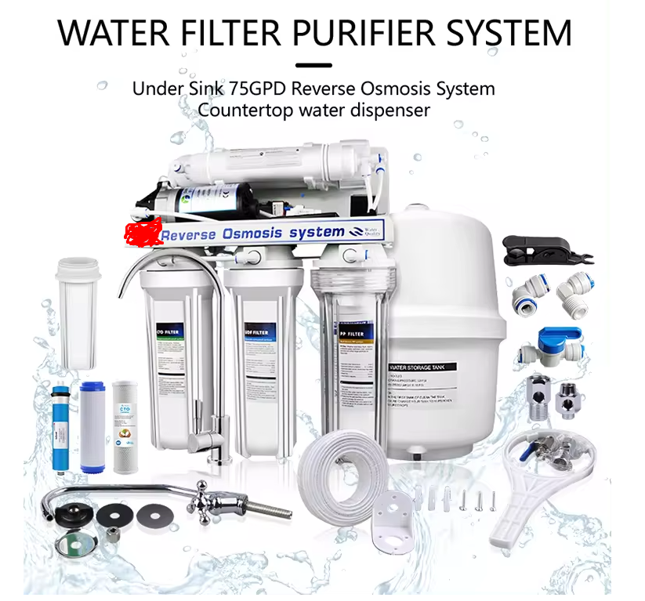

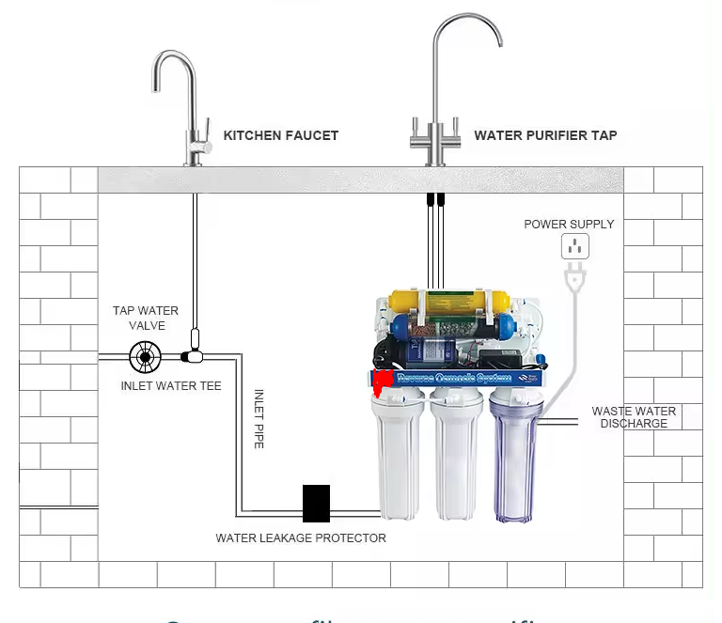

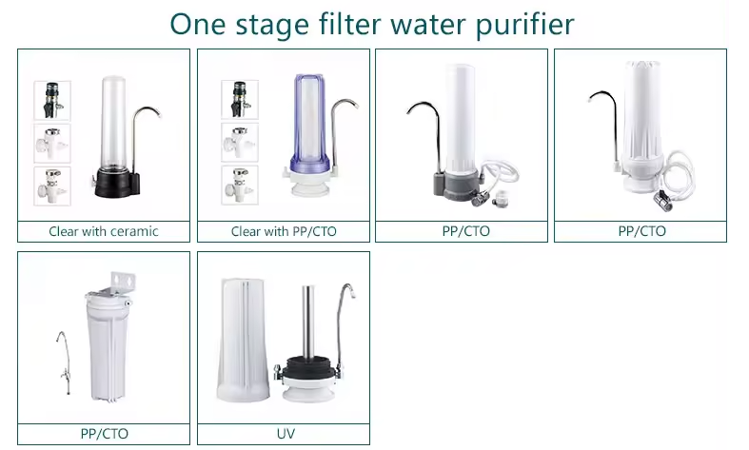

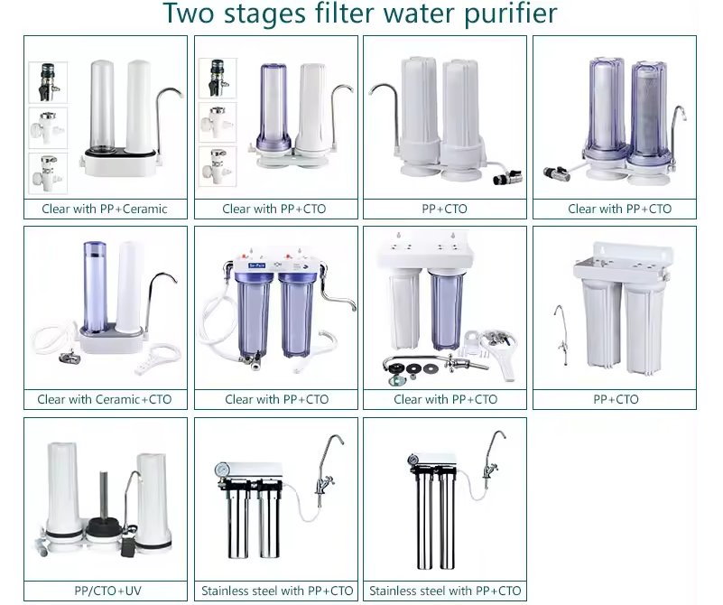

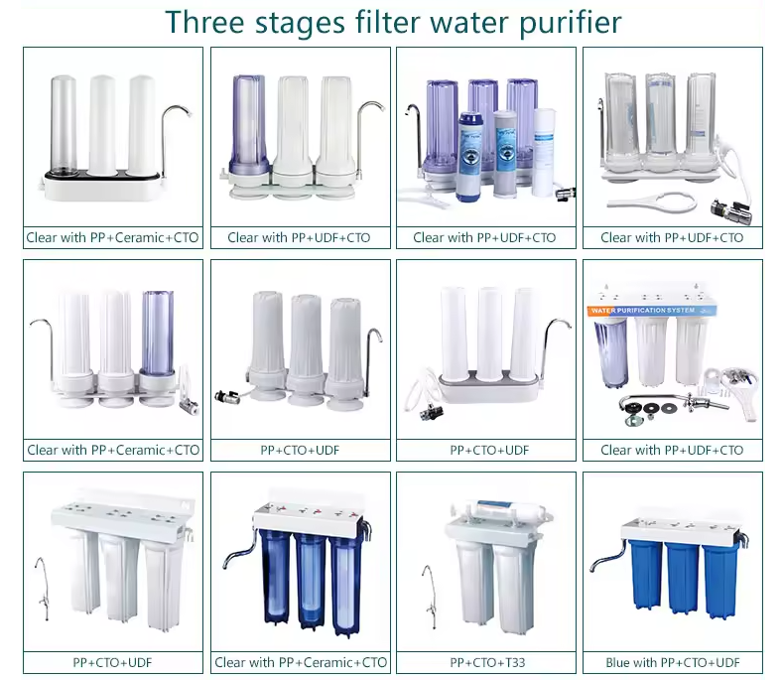

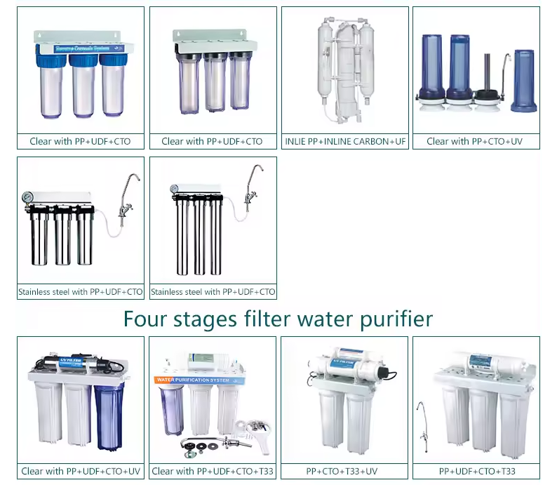

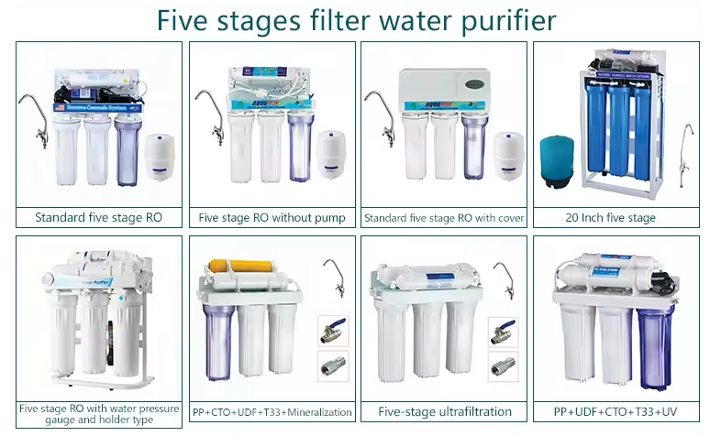

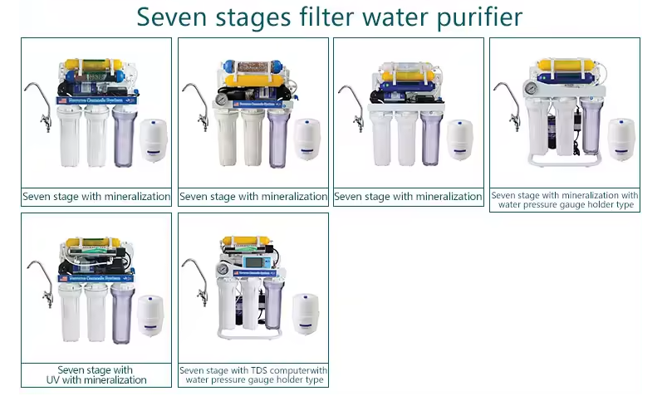

<https://www.alibaba.com/product-detail/iSpring-RCC7AK-6-Stages-Under-Sink_62472343794.html?spm=a2700.galleryofferlist.normal_offer.d_title.49d75148SaSQjp>

# iSpring RCC7AK 6 Stages Under Sink Water Purifier Mineral Machines

50 - 499 sets

**$33.50**

500 - 1225 sets

**$32.00**

>= 1226 sets

**$30.00**

**Key attributes**

**Industry-specific attributes**

Warranty

1 Year

Application

Hotel, Commercial, Household

**Other attributes**

Place of Origin

Zhejiang, China

After-sales Service Provided

Free spare parts, Onsite Installation, Return and Replacement

Power Source

Electric, Manual

App-Controlled

NO

RO Filter Life

24 Months

Function

TDS Monitoring, self-cleaning, Filter Life Display, Smart Faucet

Filtration Stages

≥8

Brand Name

AR

Model Number

AR01-D

Power (W)

No pump,No electricity

Voltage (V)

No pump,No electricity

Type

Under-Sink

Type

Reverse Osmosis/RO

Application

iSpring RCC7AK 6 Stage Under Sink Water Purifier

Capacity

50/75/100 GPD 99% salt rejection

Filter stages

PP-GAC-CTO-RO-T33-Mineral-Transparent filter/UV

Tank

3.2 Gallon Plastic/Steel Tank

3.2Gallon Steel Tank

Normal faucet/Stainless Steel Faucet (304)

Certification

CE, RoHS,SASO

Use

Under Sink

OEM

Provided

Warranty

1 year

**Packaging and delivery**

Packaging Details

1 set ro machine 1 color carton  
tank has its individual package

Selling Units:

Single item

Single package size:

37X28X54.5 cm

Single gross weight:

10.000 kg

**Lead time**

|  |  |  |  |  |
| --- | --- | --- | --- | --- |
| Quantity (sets) | 1 - 50 | 51 - 500 | 501 - 1000 | > 1000 |
| Lead time (days) | 10 | 12 | 15 | To be negotiated |

**Samples**

Maximum order quantity: 100 set

Sample price:

**$33.50/set**

Order sample

**Overview**

**Video Description**

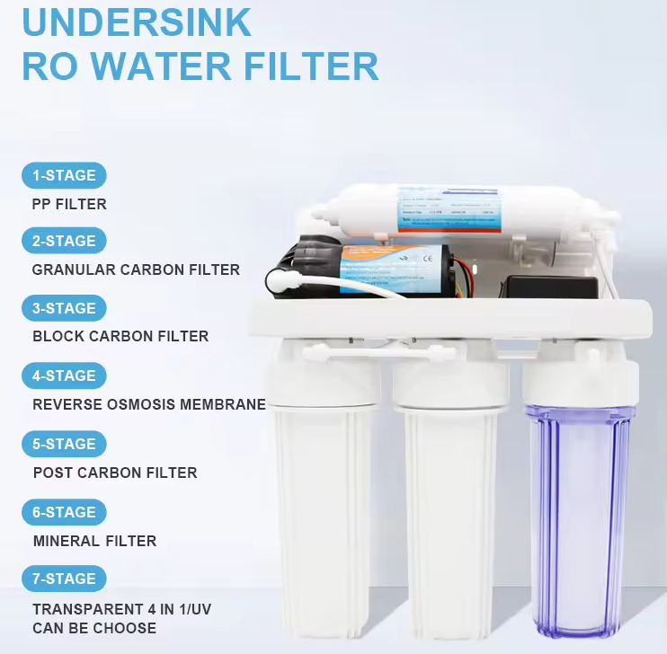

|  |  |
| --- | --- |
| Item No. | HOME WATER PURIFIER AR01-A |
| Capacity | 50G/75G/100G/200GPD/300GPD/400GPD |
| 1st stage | 10" PP Sediment Filter, 5 micron |
| 2nd stage | 10" Granular Carbon Filter |
| 3rd stage | 10" Block Carbon Filter |
| 4th stage | 99% salt rejection RO membrane |
| 5th stage | Post Carbon Filter |
| Optional 6th stage | Mineral /Alkaline |
| Optional 7th stage | Transparen 4 in 1 / 6w UV sterilizer |
| Housing | 10" white housing /10" transparent housing |
| Tank | 3.2 /4.0 G plastic tank or 3.2 G steel tank |
| Faucet | Zinc alloy faucet /304 stainless faucet |
| Pump and adaptor | 220V, 50~60Hz booster pump 1.5A~1.7A, 24V adapter |
| Machine size | 356*195*440mm |
| Package size | 370*280*545mm |
| Carton& label | 300 pcs can oem label ，500pcs can oem carton |



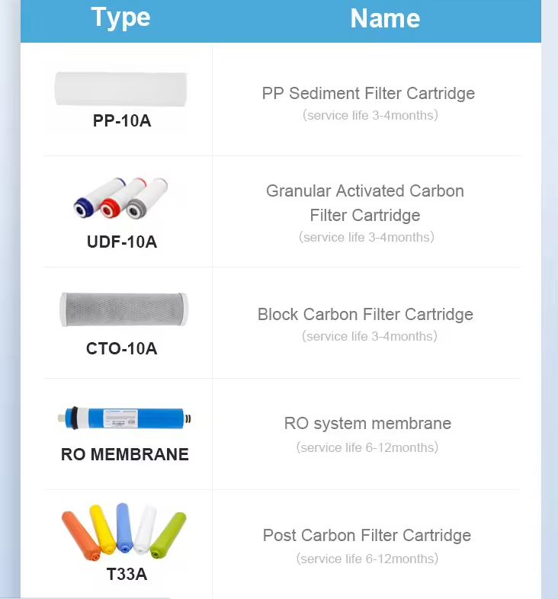

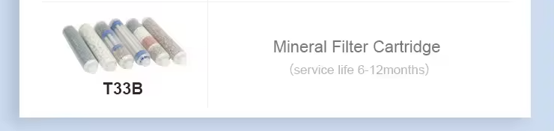



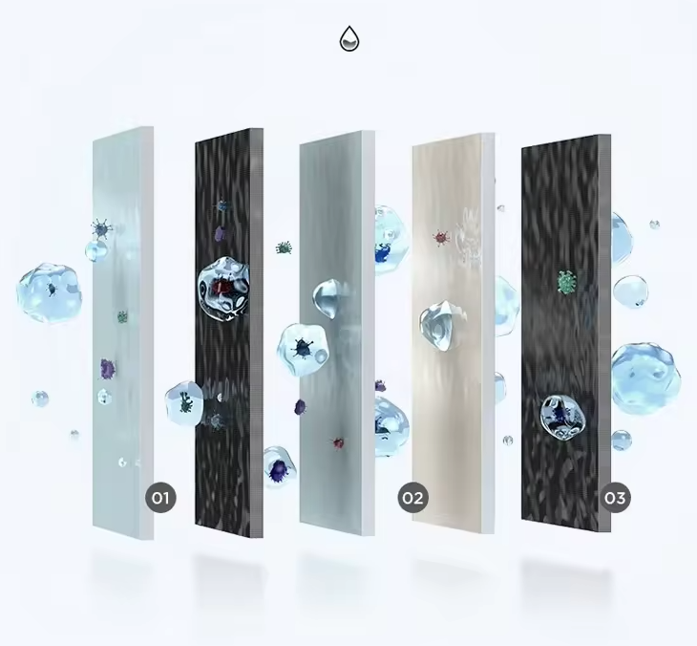

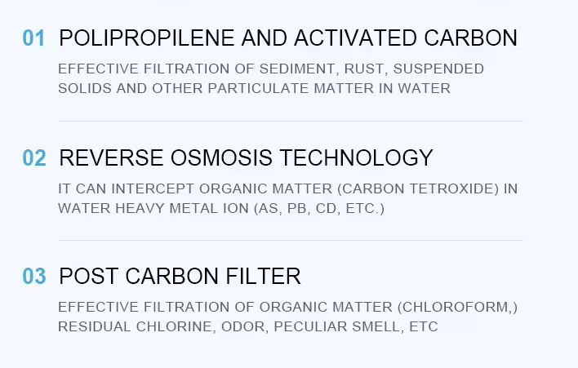

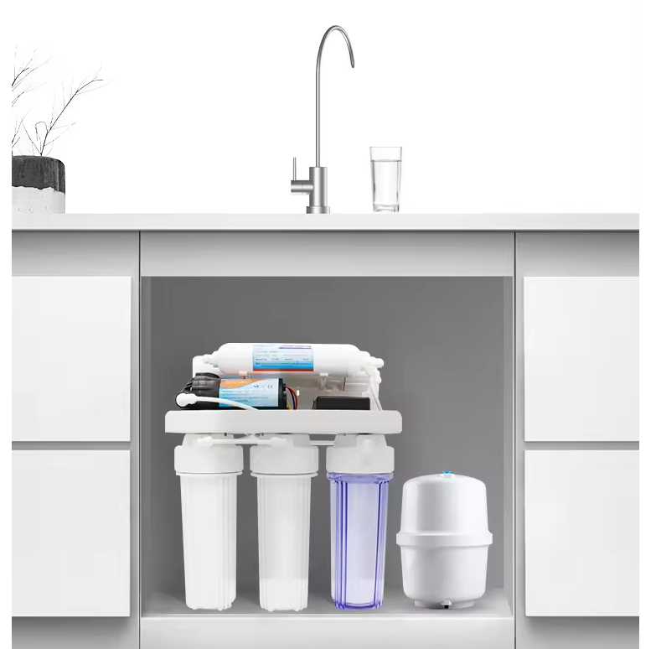

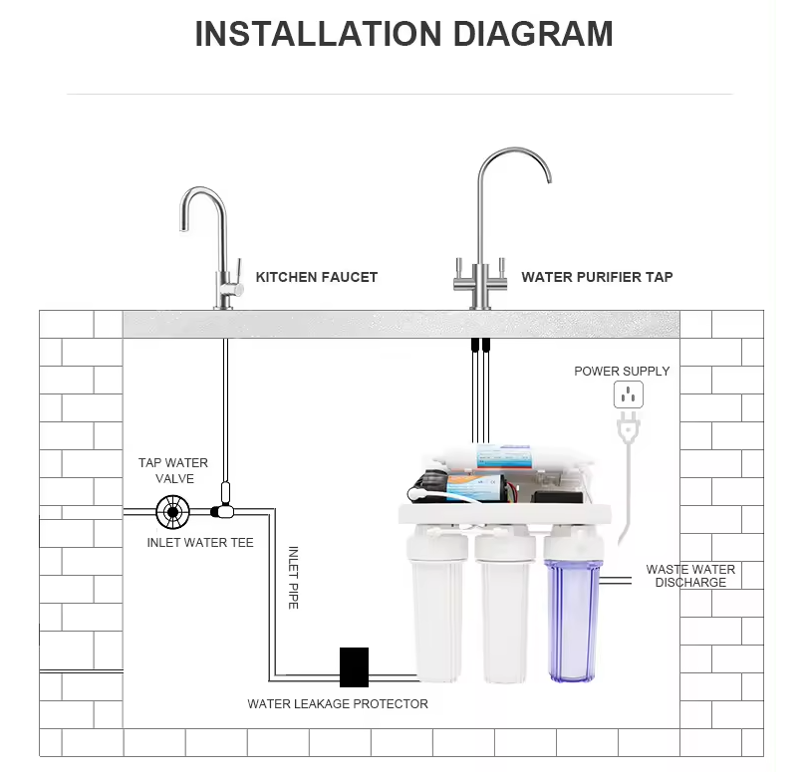

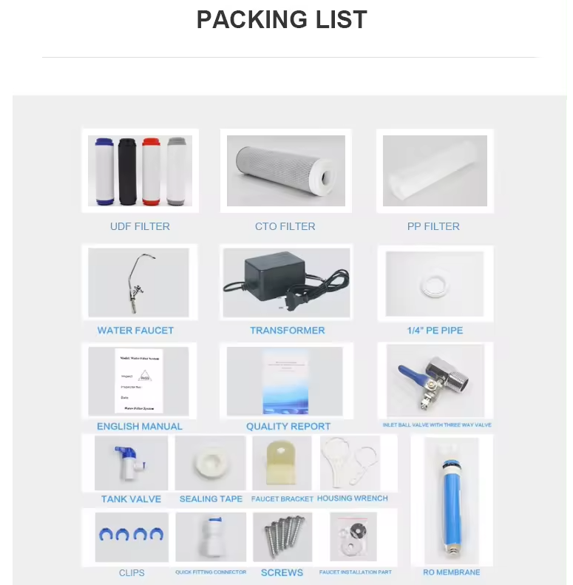

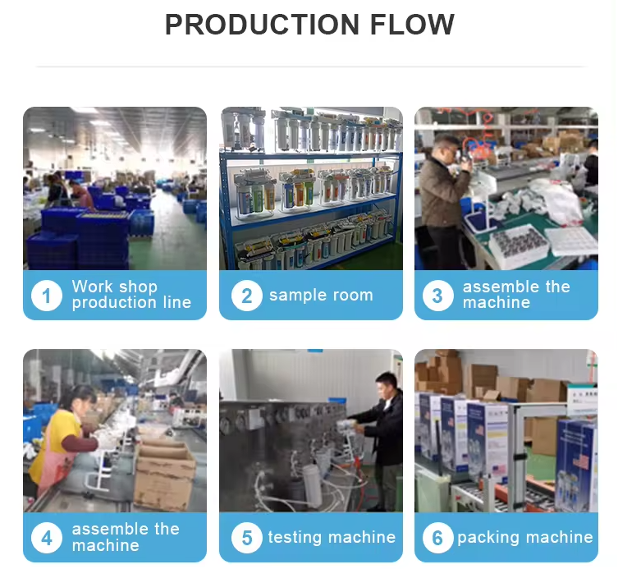

<https://www.alibaba.com/product-detail/automatic-Household-Complete-5-Stages-6stages_1600870663351.html>

# automatic Household Complete 5 Stages 6stages Kitchen New RO Water Purifier Home RO Machine water filtration system 75GPD 100GPD

>= 10 pieces

**$58.00**

**Key attributes**

**Industry-specific attributes**

Warranty

1 Year

Application

Hotel, Commercial, Household

**Other attributes**

Place of Origin

Jiangsu, China

After-sales Service Provided

Return and Replacement

Power Source

Electric

App-Controlled

NO

RO Filter Life

12 Months

Function

TDS Monitoring, self-cleaning, Filter Life Display

Filtration Stages

5

Brand Name

Ewater

Model Number

EWT-RO303B

Power (W)

300

Voltage (V)

220

Type

Under-Sink

Product name

Household Water Purifier

Application

Household Drinking Water Filtration

Color

Customized

Material

ABS Food Grade Plastic

Feature

High-effiency

Capacity

75GPD

Filter life

12-24 Months

Warranty

1 Year

Installation

Easily Installed

Filter Cartridge

PP+RO+CARBON

**Packaging and delivery**

Packaging Details

Carton Box--automatic Household Complete 5 Stages 6stages Kitchen New RO Water Purifier Home RO Machine water filtration system 75GPD 100GPD

Port

Shanghai Port

Selling Units:

Single item

Single package size:

45X15X40 cm

Single gross weight:

15.000 kg

**Supply Ability**

Supply Ability

2000 Piece/Pieces per Week

**Lead time**

|  |  |  |
| --- | --- | --- |
| Quantity (pieces) | 1 - 100 | > 100 |
| Lead time (days) | 10 | To be negotiated |

**Samples**

Maximum order quantity: 1 piece

Sample price:

**$40.00/piece**

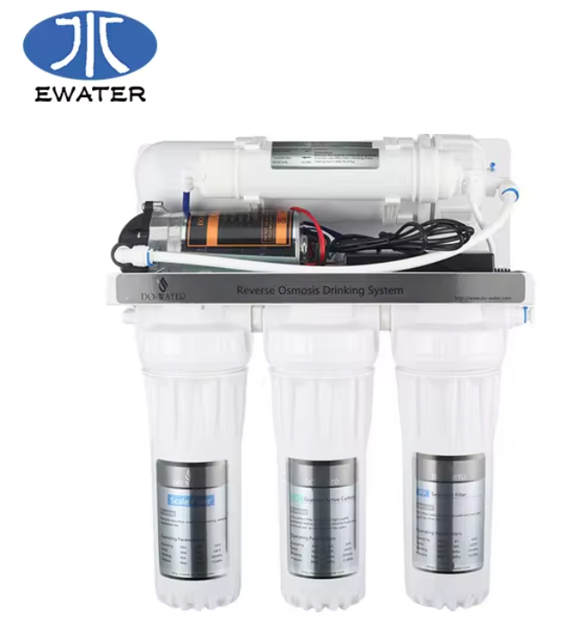

**Household Complete 3 Stages Kitchen New RO Water Purifier Home RO Machine Portable**

1.PP fiber cotton to remove sand,rust,suspended matters,and other particles.

2.KDF+CTO cartridge will remove heavey metals,chlorine,and adsorb bad smell odors and organics.   
3.The ion exchange resin cartridge will remove the Ca,Mg ions.   
4.The mineralization cartridge is to add trace elements to the water.   
5.The medical stone cartridge include ceramic materials,and it can activate the water and help to add more healthy elements.  
6.BIO anion cartridge will make the water alkaline and healthier.  
7.The UF(ultrafiltration) hollow fiber cartridge deeply filtrate virus,pathogen,organics,and other ultramicron larger than 0.01 micron.   
8.Silver-added activated carbon will further remove odors,chlorine that may remain,and will also improve the water taste.   
9.Magnet cartridge: it helps to magnetize water and make biological effect.

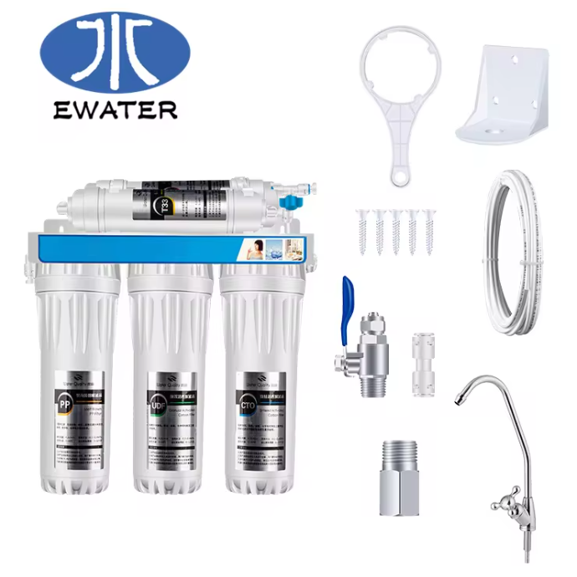

|  |  |
| --- | --- |
| **75GPD STANDING MODEL WITH PRESSURE METER** | |
| Inlet Pressure | 0.1Mpa-0.35Mpa |
| Temperature | 5-38℃ |
| Adaptor | 1.2A/24V |
| Input Power | 100V-240V,50/60HZ |
| Operating Pressure | 0.4Mpa-0.6Mpa |
| Tank | 3.0G Tank |
| Membrane | 50/75GPD |
| Booster Pump | 8806/24Dertin |

Applications

1）Wash vegetables&fruits,the purified water is much cleaner.The fruits and vegetables is more safety to eat after washing.  
2）Cooking rice and soup,the purified water retains the mineral substance and microelement which is helpful to human body when remove the bad things in the water.Make the foods safer,improve taste.

3）Powdered milk,remove the impurities in the water,protect baby safety.  
4）Drinking tea,the purified water is more healthy for human body and good taste.  
5）Brush teeth&Wash face,the purified water will make your skin glamorous.

<https://www.alibaba.com/product-detail/APEC-5-stages-gray-color-home_1600144481487.html?spm=a2700.galleryofferlist.normal_offer.d_title.51aca74cNIAK2l>

# APEC 5 stages gray color home RO purifier water filter system

50 - 499 pieces

**$33.00**

500 - 1225 pieces

**$31.50**

>= 1226 pieces

**$29.80**

**Key attributes**

**Industry-specific attributes**

Warranty

1 Year

Application

Hotel, Commercial, Household

**Other attributes**

Place of Origin

Zhejiang, China

After-sales Service Provided

Free spare parts, Onsite Installation, Return and Replacement

Power Source

Electric, Manual

App-Controlled

NO

RO Filter Life

18 Months

Function

TDS Monitoring, self-cleaning, Filter Life Display, 0.0001 micron filtration

Filtration Stages

≥8

Brand Name

AR

Model Number

AR01-D

Power (W)

no pump

Voltage (V)

no electricity

Application

Household Drinking Water Filtration

Installation

Easily Installed

Usage

Under Sink

Tank

3.2/4.0 G plastic/steel tank

OEM

Provided Logo

Color

White/Gray

Stage

5/6/7/8 stages

Warranty

1 year

Weight

9.5 kgs

Certification

CE, RoHS, ISO, SASO

**Packaging and delivery**

Packaging Details

300 pcs can OEM carton and label

Selling Units:

Single item

Single package size:

0.37X0.28X0.54 cm

Single gross weight:

9.500 kg

**Lead time**

|  |  |  |  |  |
| --- | --- | --- | --- | --- |
| Quantity (pieces) | 1 - 50 | 51 - 500 | 501 - 1226 | > 1226 |
| Lead time (days) | 5 | 10 | 20 | To be negotiated |

**Samples**

Maximum order quantity: 50 piece

Sample price:

**$33.00/piece**

Order sample

<https://www.amazon.com/Home-Master-TMULTRA-ERP-Undersink-Reverse/dp/B01N4P2MII?th=1>

# Home Master TMULTRA-ERP-L Ultra RO System Loaded; City & Well Water, Fast 4.5 sec Fill Rate, 6-stages, UV Sterilizer, 1:1 Waste Ratio, High hardness Membrane 18gpg, Lux Nickel RO Faucet, fridge kit

* TMULTRA-ERP-L Loaded

2 options from $552.90

* 4 Count (Pack of 1)

12 options from $86.73

* TMULTRA

- -

* TMULTRA-ERP w/ Pump

1 option from $489.50

|  |  |
| --- | --- |
| **Brand** | Home Master |
| **Special Feature** | 4.5s Fill Rate, KDF85 Iron Prefiltration, LED UV, Hygienic Modular Design |
| **Package Information** | Canister |
| **Power Source** | Corded Electric |
| **Model Name** | Home Master TMULTRA-ERP-L Ultra RO System Loaded; City & Well Water, Fast 4.5 sec Fill Rate, 6-stages, UV Sterilizer, 1:1 Waste Ratio, High hardness Membrane 18gpg, Lux Nickel RO Faucet, fridge kitHome Master TMULTRA-ERP-L Ultra RO System Loaded; City & Well Water, Fast 4.5 sec Fill Rate, 6-stages, UV Sterilizer, 1:1 Waste Ratio, High hardness Membrane 18gpg, Lux Nickel RO Faucet, fridge kit |
| **Lower Temperature Rating** | 40 Degrees Fahrenheit |
| **Maximum Flow Rate** | 1 Gallons Per Minute |
| **Operating Pressure Range** | 40-95 PSI |
| **Upper Temperature Rating** | 100 Degrees Fahrenheit |

**About this item**

* A better RO system | Home Master Ultra’s innovative design solves most common problems associated with canister and tankless RO systems
* Increased Luxury and Performance | Loaded model includes brushed nickel RO Faucet, Fridge Connection Kit, and Dow Filmtec High Performance High Hardness RO Membrane (0.0001 micron, 75GPD)
* EPA Registered | Home Master UV Sterilizer is registered under EPA 97952-AZ-1 and has been approved to kill, inactivate or suppress growth of viruses, bacteria, fungi in water purification devices
* 4.5 second Fill Rate | 6-stages of filtration, UV sterilization and purification remove up to 99% of Chlorine and chloramines, chemicals, lead, heavy metals, fluoride, microplastics, TDS, and thousands more. BPA and Lead free. 5 Year Limited Warranty
* Reduced Water Waste & TDS Creep | Built in non-electric permeate pump reduces TDS creep and water waste up to 80%, increases water production up to 50%, for about a 1:1 waste ratio.

## From the manufacturer

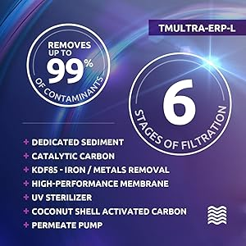

### Solutions, Not Compromises – Home Master Ultra Reverse Osmosis Undersink Water Filtration System with Permeate Pump Loaded

The Home Master **Ultra**with **Permeate Pump** **Loaded**Undersink Reverse Osmosis System delivers solutions, not problems. Even the most health conscious individuals will be impressed with its exceptional water purity – it removes up to 99% of chlorine, iron and other metals while safely sterilizing 99.99% of microorganisms, viruses, and bacteria. The built-in non-electric Permeate Pump provides a near 1:1 waste to purified water ratio. Home Master’s innovative modular design eliminates common problems like canister filter housing leaks, slow flow, water waste, service challenges, and tankless TDS creep.

This Loaded model adds an elegant Luxury Standard Brushed Nickel RO Faucet with a ¼ turn ceramic valve, a 15’ refrigerator connection kit w/ shut-off valve for the added convenience of connecting to your water and ice center, and the Dow Filmtec (0.0001-micron 75GPD) high performance high hardness RO membrane for better performance and longer life on high hardness water supplies up to 18gpg.



### Perfecting Your Water - Clean, Refreshing Water - Fast

Home Master Ultra uses sediment, iron, and catalytic carbon filtration, and reverse osmosis purification to remove up to99% of iron, hydrogen sulfide, chlorine, chloramines, chemicals, heavy metals, fluoride, TDS, pharmaceuticals, microplastics, and 1000s of other contaminants (DOW Filmtec 0.0001-micron).**The IRON pre-filter contains KDF85 redox media to remove up to 1ppm dissolved iron.**The UV (254nm) sterilization chamber is always on guard and safely destroys 99.99% of germs, viruses, bacteria, & microorganisms without dispensing hot water.

Many tankless RO systems use imported ‘loose’ style membranes which can only achieve up to 94% reduction in total dissolved solids including heavy metals. Those membranes are intentionally loosely wound to allow for more flow, sacrificing purity to compensate for not having a storage tank. Home Master uses only the highest quality American made Dow 0.0001 micron RO membranes which can achieve up to 99% reduction in TDS including heavy metals.



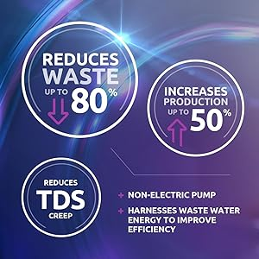

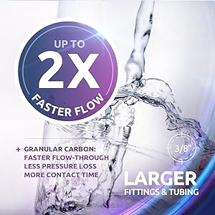





### The Power of UV Light

Home Master has discovered that using ultraviolet light filtration has many advantages in fighting microorganisms. UV light is more effective than chlorine in eliminating viruses – all without using harmful chemicals. As the water enters the UV sterilization chamber, it’s bombarded with intense light waves (254um). This light penetrates the cell wall of living microorganisms, attacking their DNA, rendering them dead or unable to reproduce.

The EPA has recognized UV technology as one of four approved water sterilization methods, and is actually the #1 preferred due to its instantaneous results. The Home Master EPA registered UV sterilizer operates for a full year at 17,000-mws/cm. We recommend changing the UV bulb and filters once a year for optimal performance.

The Home Master Ultra undersink RO UV sterilizer is registered under EPA #97952-AZ-1 to kill, inactivate, or suppress growth of germs, viruses, bacteria, fungi, and other microorganisms in the water.

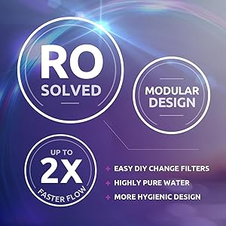

#### What's In The Box

* Full assembled purification unit which includes the RO membrane and filters
* 3.2-gallon Storage Tank
* 3/8" feed-water adapter with shut off valve
* Permeate pump + High hardness, high performance Dow Filmtec RO Membrane 75GPD
* Luxury Standard RO faucet
* Fridge Connection Kit
* 110v power supply
* Drain saddle + DIY instructions

#### The Perfect Choice

With so many different RO systems, selecting the right one can be difficult. Choose a system that produces consistently pure, great-tasting water on tap – removes iron, destroys 99.99% of microorganisms, has a reliable and easy-to-use energy efficient design, provides a fast flow rate, and keep TDS creep at bay – all while reducing water waste.

Effective in municipal water and potable private well water conditions within the System Specifications below. You may submit a copy of your water report for a recommendation.

General System Specifications: Electrical requirement: Standard household outlet: 110v. Feed water: PSI 40 - 90 PSI. Feed water Temperature: 40 - 100°F Max TDS: 2000 ppm. Max. Hardness: 10 gpg. pH limits: 4 - 10. Iron bacteria: zero. Iron: 1 ppm.

DIMENSIONS: Purification cluster – 16” high x 15” wide x 5” deep, Reserve tank – 15” high x 11” diameter.

**BPA Free | Lead Free | EPA #97952-AZ-1**

|  |  |  |  |  |  |  |
| --- | --- | --- | --- | --- | --- | --- |
|  | **[home master tm](https://www.amazon.com/dp/B0197YOKXW?ref=emc_s_m_5_i_atc)** | **[home master tmafc](https://www.amazon.com/dp/B005A3WM6C?ref=emc_s_m_5_i_atc)** | **[Home Master TMAFC-ERP](https://www.amazon.com/dp/B00N2941T2?ref=emc_s_m_5_i_atc)** | **[home master tmultra](https://www.amazon.com/dp/B005A3WMNA?ref=emc_s_m_5_i_atc)** | **[home master tmultra-erp-l](https://www.amazon.com/dp/B01N4P2MII?ref=emc_s_m_5_i_atc)** | **[home master tmhp](https://www.amazon.com/dp/B00N2941N8?ref=emc_s_m_5_i_atc)** |
|  | [**Home Master TM Undersink Reverse Osmosis System**](https://www.amazon.com/dp/B0197YOKXW?ref=emc_s_m_5_i_atc) | [**Home Master TMAFC Artesian Full Contact**](https://www.amazon.com/dp/B005A3WM6C?ref=emc_s_m_5_i_atc) | [**Home Master TMAFC-ERP Artesian Full Contact With Permeate Pump**](https://www.amazon.com/dp/B00N2941T2?ref=emc_s_m_5_i_atc) | [**Home Master Ultra TMULTRA**](https://www.amazon.com/dp/B005A3WMNA?ref=emc_s_m_5_i_atc) | [**Home Master TMULTRA-ERP-L with Permeate Pump Loaded**](https://www.amazon.com/dp/B01N4P2MII?ref=emc_s_m_5_i_atc) | [**Home Master TMHP HydroPerfection**](https://www.amazon.com/dp/B00N2941N8?ref=emc_s_m_5_i_atc) |
|  | [See Details](https://www.amazon.com/dp/B0197YOKXW?ref=emc_s_m_5_i_atc) | [See Details](https://www.amazon.com/dp/B005A3WM6C?ref=emc_s_m_5_i_atc) | [See Details](https://www.amazon.com/dp/B00N2941T2?ref=emc_s_m_5_i_atc) | [See Details](https://www.amazon.com/dp/B005A3WMNA?ref=emc_s_m_5_i_atc) | [See Details](https://www.amazon.com/dp/B01N4P2MII?ref=emc_s_m_5_i_atc) | [See Details](https://www.amazon.com/dp/B00N2941N8?ref=emc_s_m_5_i_atc) |
| Customer Reviews | *4.5 out of 5 stars*  81 | *4.8 out of 5 stars*  2,491 | *4.8 out of 5 stars*  2,491 | *4.7 out of 5 stars*  307 | *4.7 out of 5 stars*  307 | *4.7 out of 5 stars*  1,190 |
| Removes up to 99% of chemical, TDS, and metals* | Yes | Yes | Yes | Yes | Yes | Yes |
| Waste Ratio | 4:1 | 4:1 | 1:1 | 4:1 | 1:1 | 1:1 |
| Fast Flow RO! Kit | Yes | Yes | Yes | Yes | Yes | Yes |
| Removes Iron | No | No | No | Yes | Yes | Yes |
| Destroys Viruses and Microorganisms with UV | -- | -- | -- | 99.9% | 99.9% | 99.9% |
| Full contact technology | No | Yes | Yes | No | No | Yes |
| Artesian Mineral Water on Tap | No | Yes | Yes | No | No | Yes |
| Reduces Storage Tank Degradation | No | Yes | Yes | Yes | Yes | Yes |
| Reduces TDS Creep | No | No | Yes | No | Yes | Yes |
| Water Production (GPD) | 50 | 50 | 50 | 50 | 75 | 50 |